

Key Instant Recall
Facts for Mathematics

To develop children’s fluency in mathematics, we ask them to learn key instant recall facts each half term. We expect children to practise their KIRFs daily.

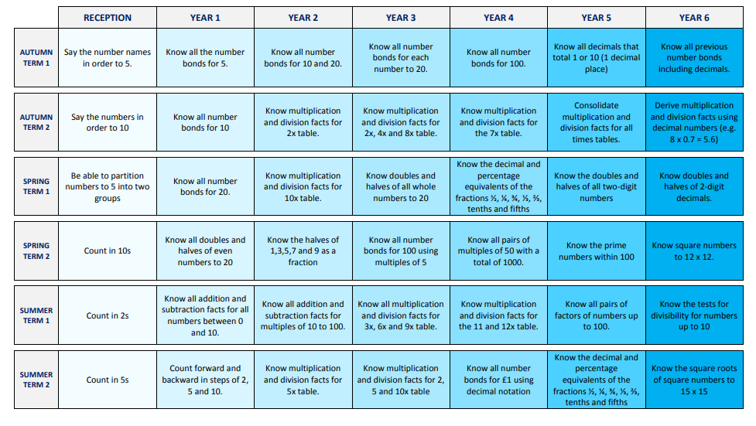
Overview of the Key Instant Recall Facts term by term
Year 2
Year 3
Counting and Place Value | Number Bonds | Addition & Subtraction
- Count from 0 in multiples of 100  - Count from 0 in multiples of 50 (E.g. How many 50s make 300? Multiply 50 by 6. What are 4 lots of 50?)  - Count from 0 in multiples of 4  - Count from 0 in multiples of 8  - Count in 4s from any given number, forwards and backwards  - Count in 3s from any given number, forwards and backwards  - Find 10 more / less than a given number  - Find 100 more / less than a given number Understand the value of H, T & Ones  - Read and write numbers to 1000 (numerals and words)  - Round numbers to the nearest 10 and 100 | - Understand the = sign in balancing equations  - Use and understand < and > signs  - Understand missing number calculations  - Know all number bonds to 100 (E.g. What do I add to 65 to make 100? What is 100 take away 6? What is 13 less than 100? How many more than 98 is 100? What is the difference between 89 and 100?)  - Visualise number bonds to 100 on a number line  - Find patterns within number bonds to 100 | - Know all addition and subtraction facts for multiples of 100 to 1000  - Know all addition and subtraction facts for multiples of 5 with a total of 100  - Know all addition and subtraction facts for number pairs with a total of 100  - Add and subtract mentally:  A three-digit number and ones  A three-digit number and tens  A three-digit number and hundreds
Doubling & Halving  Year 3 continued | Multiplication & Division Facts | Measures
- Know doubles of all multiples of 10 to 500  - Know halves of all multiples of 10 to 500  - Know doubles of all multiples of 100 to 5000  - Know halves of all multiples of 100 to 5000 | - Revise previous x and ÷ facts for 2, 3, 4, 5, 6 and 10  - Introduce 7s, 8s, 9s and 11s- recall multiplication and corresponding division facts  - x50  - x100  - Children recognise that multiples of even times tables are all even | - Recall facts about durations of time  - Know the number of seconds in a minute  - Know the number of minutes in an hour  - Know the number of hours in a day  - Know the number of days in each month, year and leap year  - Understand am and pm; noon and midnight Recognise right angles  - Know which units are used to measure length, weight and capacity

