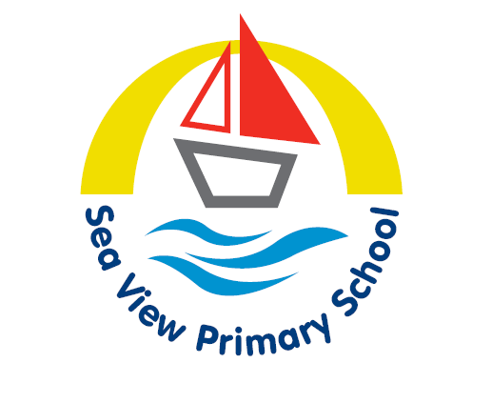

Sea View Primary School

Primary MFL Policy
Please note: This policy has been created in line with the requirements of the national curriculum, which maintained schools are legally required to follow. The teaching of a MFL is a statutory requirement at KS2 in maintained schools. Academies are not required to follow the national curriculum; however, Ofsted still expects to see a broad, rich curriculum that includes the teaching of languages in academies. Academies teaching MFL to primary-age pupils can adopt and amend this policy to suit their curriculum.

Date policy last reviewed: | 04.03.2025

Signed by:
J Weightman | Headteacher | Date:
A Newham | Chair of governors | Date:

Contents:
Statement of intent - Sea View Pedagogy

- Legal framework
- Roles and responsibilities
- The national curriculum
- Teaching and Learning (Implementation)
- Assessment
- Equal opportunities
- Careers
- Impact
- Monitoring and review

Statement of intent
At Sea View Primary School, we recognise the importance of teaching a foreign language to foster pupils’ curiosity, appreciate other cultures and deepen their understanding of the world. We recognise that language teaching encourages pupils to appreciate and celebrate difference and provides the foundation for learning further languages.
The French curriculum at Sea View Primary School is for children to develop an interest in learning other languages in an enjoyable and engaging way. The experience of learning and using a foreign language makes its unique contribution to the whole curriculum by taking children out of the familiar environment and allowing them to explore the life-style and culture of another land through the medium of its language
This policy will ensure the school complies with the requirements of the National Curriculum and provides opportunities for pupils to learn another language and acquire new ways of thinking.

Sea View Pedagogy
Our school operates in a unique context and we believe our curriculum reflects this and caters for the needs of our learners. We have developed a curriculum which promotes positive wellbeing at the core and teaches children how to lead fulfilling lives in modern Britain and to enable them to become responsible citizens of the society in which they live.
Learning is infinite and The Sea View 7C’s aim to share the pedagogy which underpins our curriculum with the children. These are Conversation, Connectivity, Curiosity, Creativity, Community and Culture, Collaboration and Consideration.
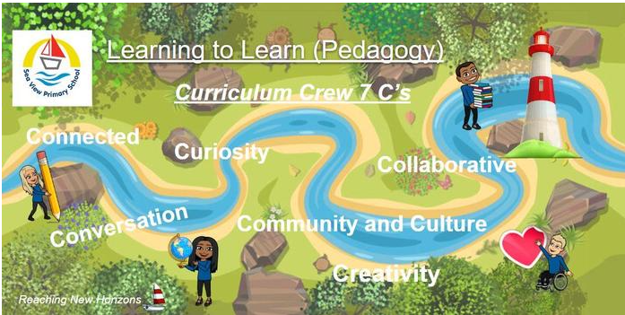
Each of our curriculum subjects has its own specialist. They understand the qualities needed to excel in each subject. They are always on hand to offer tips and advice to support the development of subject specific vocabulary and help us to make connections in our learning. The curriculum crew reflect the rich and diverse society we live in, challenging stereotypes and share qualities they possess in order to excel in their subject. As ambassadors for their subject they also showcase how their subject and qualities can provide career opportunities in the future.

Our curriculum inspires children to learn through providing real life experiences and developing their skills, knowledge and understanding in all aspects of their education including the humanities and linguistic, mathematical, scientific, technical, social, physical and artistic learning therefore providing a broad and balanced platform for learning.
Our curriculum promotes a sense of awe and wonder which develops children’s cognitive skills as well as their knowledge and understanding. It inspires and motivates children to become lifelong learners through ensuring high levels of engagement, enthusiasm and fun. It develops children as resilient learners who are happy to take risks in their learning as they understand that perseverance will lead to success. It allows children to think proactively and to articulate their understanding using high quality vocabulary. It provides children with the transferable knowledge they need for subsequent learning to build deeper understanding in a range of subjects.

A highly stimulating environment and a well organised curriculum provides rich, varied and imaginative experiences for our children which enables them to make substantial and sustained progress, developing excellent knowledge, understanding and skills considering their different starting points.

MFL at Sea View

Purpose of study
Learning a foreign language is a liberation from insularity and provides an opening to other cultures. A high-quality languages education should foster pupils’ curiosity and deepen their understanding of the world. The teaching should enable pupils to express their ideas and thoughts in another language and to understand and respond to its speakers, both in speech and in writing. It should also provide opportunities for them to communicate for practical purposes, learn new ways of thinking and read great literature in the original language. Language teaching should provide the foundation for learning further languages, equipping pupils to study and work in other countries.

Aims
The national curriculum for languages aims to ensure that all pupils:

- understand and respond to spoken and written language from a variety of authentic sources

- speak with increasing confidence, fluency and spontaneity, finding ways of communicating what they want to say, including through discussion and asking questions, and continually improving the accuracy of their pronunciation and intonation

- can write at varying length, for different purposes and audiences, using the variety of grammatical structures that they have learnt

- discover and develop an appreciation of a range of writing in the language studied.

Meet Frank French


Frank is part of our Curriculum Crew who is introduced at the start of each topic and lesson, providing a visual link to lessons and allows our children to focus on the skills needed in the upcoming tasks.
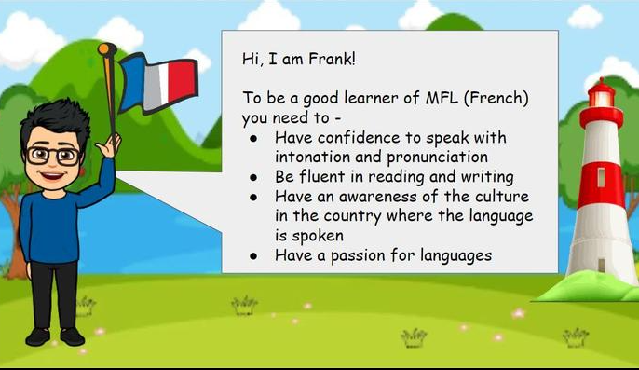
Frank is featured as part of our languages pathway journey - allowing the children to revisit and consolidate prior learning.

Legal framework
This policy has due regard to all relevant legislation and guidance including, but not limited to, the following:
- DfE (2013) ‘The national curriculum in England: Key stages 1 and 2 framework document’
- DfE (2013) ‘Languages programmes of study: key stage 2’
- Ofsted (2021) ‘Research review series: languages’
This policy operates in conjunction with the following school policies:
- Primary Curriculum Policy
- Primary Teaching and Learning Policy
- Primary Assessment Policy
- Special Educational Needs and Disabilities (SEND) Policy

Roles and responsibilities
The governing board is responsible for:
- Ensuring that the school teaches pupils a language as part of a broad and balanced curriculum, and in line with statutory guidance.
- Ensuring the school’s MFL curriculum is accessible to all pupils.
The headteacher is responsible for:
- The overall implementation of this policy.
- Ensuring the school’s MFL curriculum is implemented consistently.
- Ensuring appropriate resources are allocated to the MFL curriculum.
- Ensuring all pupils are appropriately supported.
- Appointing a member of staff to lead on the school’s approach to teaching MFLs.
The SENCO is responsible for:
- Collaborating with the headteacher to ensure the curriculum is accessible to all and teaching follows the Equality Act 2010.
- Carrying out SEND assessments where necessary and ensuring pupils receive the additional help in MFL they need.
The MFL subject lead is responsible for:
- Preparing policy documents, curriculum plans and schemes of work for MFL.
- Reviewing changes to the national curriculum and advising on their implementation.
- Monitoring the learning and teaching of MFLs, providing support for staff where necessary.
- Organising the deployment of resources and carrying out an annual audit of all MFL resources.
- Leading staff meetings and providing relevant staff with the appropriate training.
- Advising on the contribution of MFL to other curriculum areas.
Teaching staff are responsible for:
- Acting in accordance with this policy.
- Ensuring that lessons are taught in line with the school’s Health and Safety Policy at all times.
- Liaising with the MFL lead about key topics, resources and support for individual pupils if required.
- Ensuring that all relevant statutory content is covered within the school year.
- Monitoring the progress of pupils in their class and reporting this on an annual basis.
- Reporting any concerns regarding the teaching of the subject to a member of the SLT.
- Undertaking any necessary training or CPD.

The national curriculum
The national curriculum will be followed for all MFL teaching.
Teaching will focus on enabling pupils to make substantial progress in one language, with an emphasis on practical communication. The school’s chosen language is French. Teaching will provide an appropriate balance of spoken and written language, laying the foundations for further foreign language teaching at KS3. Pupils will be taught for the equivalent of one hour per week in a whole-class setting.
In line with the national curriculum, pupils will be taught by the end of KS2 to:
- Listen attentively to spoken language and show understanding by joining in and responding.
- Explore the patterns and sounds of language through songs and rhymes and link the spelling, sound and meaning of words.
- Engage in conversations - asking and answering questions, expressing opinions and responding to those of others, and seek clarification and help.
- Speak in sentences, using familiar vocabulary, phrases and basic language structures.
- Develop accurate pronunciation and intonation so that others understand when they are reading aloud or using familiar words and phrases.
- Present ideas and information orally to a range of audiences.
- Read carefully and show understanding of words, phrases and simple writing.
- Appreciate stories, songs, poems and rhymes in the language.
- Broaden their vocabulary and develop their ability to understand new words that are introduced into familiar written material, including through using a dictionary.
- Write phrases from memory, and adapt these to create new sentences and express ideas clearly.
- Describe people, places, things and actions orally.
- Understand basic grammar appropriate to the language being studied (e.g. feminine, masculine and neuter forms and the conjugation of high-frequency verbs); key features and patterns of the language and how to apply these, for instance, to build sentences and how these differ from or are similar to English.
Modifications will be made to the national curriculum where appropriate to meet the individual and differentiated needs of pupils.

Teaching and Learning (Implementation)
At Sea View Primary School, we follow the ‘North Tyneside Primary Languages’ scheme of work to ensure coverage and progression across school. Opportunities are promoted through children developing their skills of communication by listening, speaking, reading and writing, with an aim of making substantial progress in one language.
From Year 3-6, children will focus on various units throughout the year (see Medium Term Plan).

Listening and responding

Children should be taught how to listen carefully and discriminate sounds, identify meaning and develop auditory awareness. Teachers should use the following activities:

- respond on hearing a certain word(s), structures or phrases, e.g. put up hands, hold up an object, picture or word card, stand up;

- listen and respond to songs, poems or stories, and listen for certain details, information, repeated words or rhyming words;

- play games that require concentration on listening, such as 'Simon says', 'bingo' or 'true or false';

- respond to what they hear by performing an action or answering a question;

- pick out specific details from longer passages of familiar language, e.g. name, place, cost;

- listen to audio, CD-ROM and note down information;

- listen to and attempt to retain a sequence of numbers, letters or words which children then repeat, e.g. Je vais à Paris, elle va à Lille, il va à Nantes.

Oracy: Speaking

The focus should be on correct pronunciation and intonation.
Activities might include:

- reinforcement activities using visual aids;

- joining in with songs, poems and rhymes and then learning them by heart;

- integrating previously learnt language with newly learnt language;

- taking part in pair and group work, e.g. finding out and exchanging
information, devising sketches and role plays; engaging in conversations and asking/answering questions.

Reading and responding

Techniques used and developed during children's work in literacy should be used. Activities should include:

- replacing visual cues gradually with text cues;

- reading new words by sounding out and blending their separate parts;

- sounding out syllables in words to help memory;

- playing word games, e.g. word and picture dominoes, matching pairs; sorting and dictionary work;

- shared reading of short fiction and non-fiction texts including different text types e.g. poems.

Writing

Activities might include:

- finger writing in the air;

- writing new words by combining the spelling patterns of their sounds;

- dictating words with similar phonemes/ tricky words on mini whiteboards;

- dictating verbs and sentences;

- making labels and posters;

- acrostic poetry, shape poetry;

- creating and extending sentences using familiar language;

- using a familiar structure as a framework for creative writing.

Curriculum planning
Teachers will plan the teaching of MFL effectively and appropriately to ensure all pupils are given the opportunity to reach their full potential. All relevant staff will be briefed on the school’s long, medium and short term planning procedures as part of staff training and in accordance with the schools Primary Teaching and Learning Policy.
The curriculum and lessons will be planned carefully to allow pupils to progress by considering the building blocks of the subject – the language’s phonics, vocabulary and grammar – and the sequence of these blocks.
Lessons will use a variety of sources to model the language and encourage engagement from pupils, balancing visual, auditory, and kinaesthetic elements so that pupils with different learning styles can benefit. Teachers will use of a range of media, including videos, games, books and songs to maximise interest and make connections to real life situations.
Pupils will be taught to understand and communicate ideas, facts and feelings in speech and writing, focussed on familiar and routine matters, using their knowledge of phonology, grammatical structures and vocabulary. Vocabulary will be built into the curriculum, with the choice of the vocabulary carefully considered in line with the age of pupils and how often words occur in the language.
Planned revisiting of curriculum content will be scheduled to increase pupils’ automatic and fluent recall and ensure that words are retained in long-term memory.
Extra-curricular activities and trips that can complement pupil’s learning in the classroom and encourage personal development will be considered and planned by the MFL subject leader and the headteacher.
- Assessment
The school will undertake a programme of internal assessments to support pupils’ learning and progress in line with the school’s Primary Assessment Policy.
Formative assessments will take place throughout a scheme of work and will be used to identify pupils’ strengths and gaps in their skills and knowledge, and to identify next steps for learning.
Summative assessments will take place on a termly basis and will be used to assess pupils’ knowledge and skills following completion of a scheme of work. Records will be kept of pupils’ performance in internal assessments on the one page profile sheets.
The school will inform pupils’ parents about their child’s performance in internal assessments during parents’ evenings.
The school will communicate with its local and affiliated secondary schools where possible to support consistency and cross-phase planning regarding the teaching of MFL, ensuring that prior learning can be accounted for.

Equal opportunities
All pupils will be given equal access to the MFL curriculum and pupils with SEND will be supported to take part in whole-class lessons wherever necessary. Reasonable adjustments and additional support will be provided in collaboration with the school SENCO, pupils, parents and other relevant professionals.
Strategies which help children with S.E.N. achieve success should be used including: varied and clear illustrative materials, clear practical tasks designed to build confidence, repetition (whole class, group, pair).

Teaching staff will have high but reasonable expectations for pupils with SEND and will not take the view that some pupils are unable or unlikely to succeed in MFL.
Where it is inappropriate for a pupil to participate in a specific lesson because of reasons related to any protected characteristics, the lesson will be adapted to meet the pupil’s needs and alternative arrangements involving extra support will be provided where necessary.

Careers
Our curriculum is ambitious for all pupils and wherever possible links to career aspirations are made. Each subject is explored to demonstrate the potential careers it could support in the future.
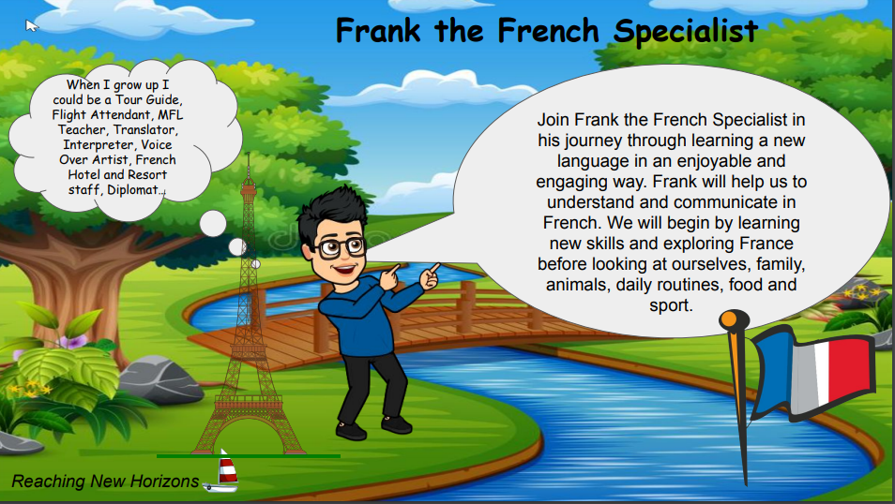
- Impact
After the implementation of North Tyneside Primary Languages, pupils should leave school equipped with a range of language-learning skills to enable them to study French, or any other language, with confidence at Key Stage 3.
The expected impact of following the North Tyneside Primary Languages’ French scheme of work is that children will:
• Be able to engage in purposeful dialogue in practical situations (e.g., ordering in a cafe, following directions) and express an opinion.
• Have an increase in enjoyment and understanding of different languages and cultures.
• Make increasingly accurate attempts to read unfamiliar words, phrases, and short texts.
• Speak and read aloud with confidence and accuracy in pronunciation.
• Demonstrate understanding of spoken language by listening and responding appropriately.
• Use a bilingual dictionary to support their language learning.
• Be able to identify word classes in a sentence and apply grammatical rules they have learnt.
• Have developed an awareness of cognates and near-cognates and be able to use them to tackle unfamiliar words in French, English, and other languages.
• Be able to construct short texts on familiar topics.
• Meet the end of Key Stage 2 stage expectations outlined in the national curriculum for Languages.
• Be at either Expected or Working Above the expected level for their age.
• Show progression in their skills, understanding and knowledge by the work in their books.
• Be able to discuss their learning and remember what they have learnt.

Teachers will assess the progress of children in their MFL through Key Stage 2 ensuring that children are supported and challenged as appropriate.

Monitoring and review
This policy will be reviewed annually by the MFL lead, in collaboration with the headteacher. Any changes made to this policy will be communicated to all members of staff and relevant stakeholders.
The scheduled review date for this policy is 04.03.27.

