

Key Instant Recall
Facts for Mathematics

To develop children’s fluency in mathematics, we ask them to learn key instant recall facts each half term. We expect children to practise their KIRFs daily.

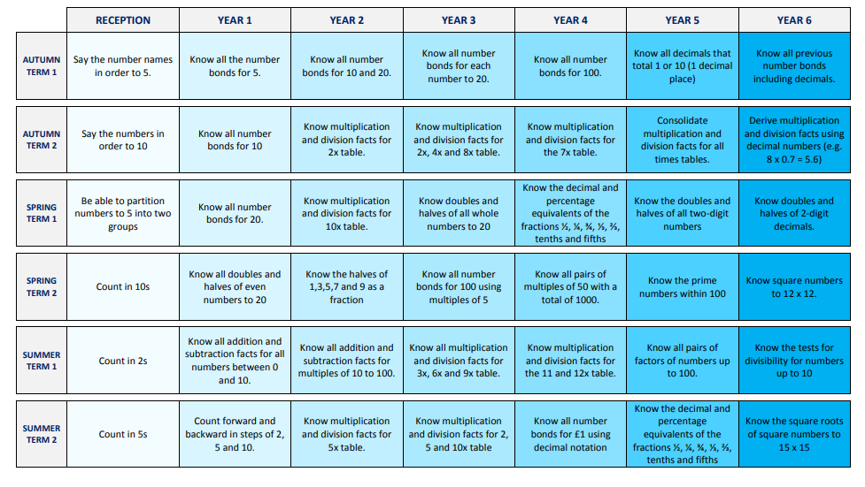
Overview of the Key Instant Recall Facts term by term
Counting and Place Value | Number Bonds | Addition & Subtraction
- Count from 0 in multiples of 25 and 1000  - Count from 0 in multiples of 6, 9, 7, 11 and 12 Understand the value of Th, H, T & Ones  - Find 1000 more / less than a given number  - Count backwards through 0 to include negative numbers  - Count on and back in tenths  - Recognise decimal equivalents of fractions for ½, ¼, ¾ and any number of tenths and hundredths  - Round numbers to the nearest 10, 100 and 1000 | - Understand the = sign in balancing equations  Year 4  - Use and understand < and > signs  - Understand missing number calculations Recognise and use factor pairs and commutativity in mental calculations  - Know all pairs of multiples of 50 with a total of 1000 | - Add and subtract pairs of two digit numbers  - Add and subtract 9/19/29 etc. to two digit numbers  - Add and subtract 11/21/31 etc. to two digit numbers
Doubling & Halving | Multiplication & Division Facts | Measures
- Know doubles and halves of all whole numbers to 50  - Know doubles and halves of all multiples of 5 to 1000  - Know doubles and halves of all multiples of 50 to 5000 | - All multiplication tables up to 12 x12 should be known by the end of Y4- including corresponding division facts  - x25  - x100  - Multiply and divide single digits by 10 and 100, including missing number problems. E.g. What is 5 multiplied by 10? What is 10 times 0.9? What is 700 divided by 70? | - Read Roman Numerals to 100  - Know the number of weeks in a year  - Know:  m in km  cm in m  90 ̊ in a right angle  Know what the terms acute, obtuse and reflex mean

